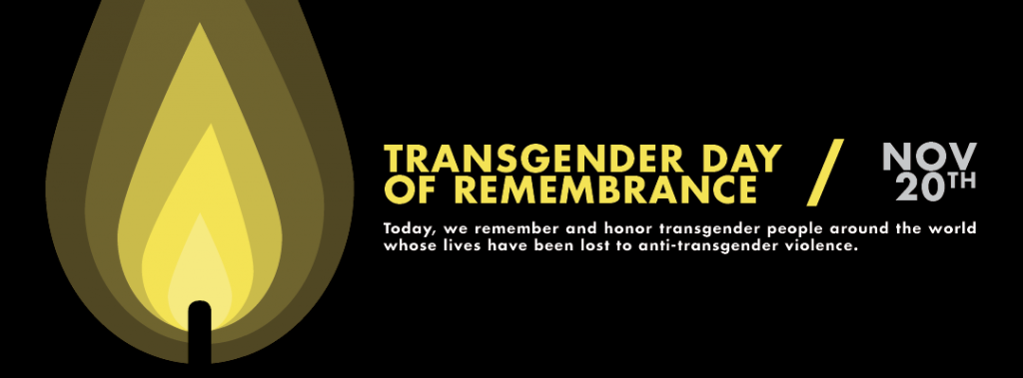
Transgender Day of Remembrance 2017
Transgender Day of Remembrance takes place on November 20, 2017. Transgender Day of Remembrance (TDoR) is a day to memorialize those who have been killed as a result of transphobia, or the hatred or fear of transgender and gender non-conforming people, and acts to bring attention to the continued violence endured by the transgender community. The Transgender Day of Remembrance was founded in 1998 by Gwendolyn Ann Smith, a transgender graphic designer, columnist, and activist, to memorialize the murder of Rita Hester in Allston, Massachusetts. Since its inception, TDoR has been held annually on 20 November, and has slowly evolved from the web-based project started by Smith into an international day of action. Typically, a TDoR memorial includes a reading of the names of those who lost their lives during the previous year and may include other actions, such as candlelight vigils, art shows, food drives, film screenings, marches, among others. The Transgender Day of Remembrance is the culmination of Transgender Awareness Week.
