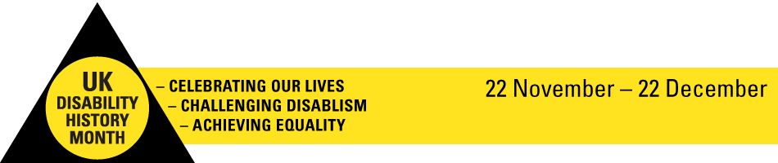

UK Disability History Month (UKDHM) is an annual event creating a platform to focus on the history of our struggle for equality and human rights. 2017 will be our eighth year and we have seen a steady increase in interest and activity since we began in 2010.

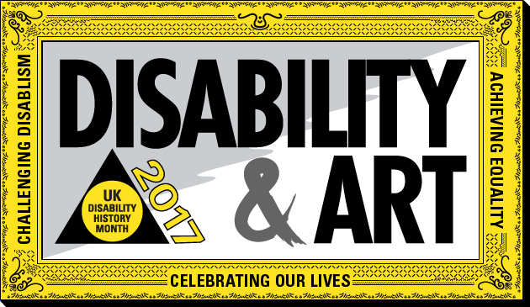

We want to examine artists who have been disabled, artists who have featured disabled people through a social model lens but also to understand the attitudes existing at different times over history towards disabled people through their portrayal in Art.
We will publish an information sheet every week during UK Disability history Month

Katya Lawder
Equality Officer

