LGBT History Month -
DWP Fylde Branch Circular
This year LGBT History Month, which runs throughout February, is focussed around “mapping our world” in terms of LGBT equality.

There have been many advances around the world in laws surrounding LGBT people, including an increase of countries where same sex marriage is now legal. However there are many places where identifying as LGBT is still a crime and in some punishable by death.
As of May 2017, LBGT citizens in 72 states still face criminalisation based on their sexual orientation and/or gender identity. Of these countries half (36) of them are members of the Commonwealth of Nations. (Based on 2017 ILGA-Europe report)

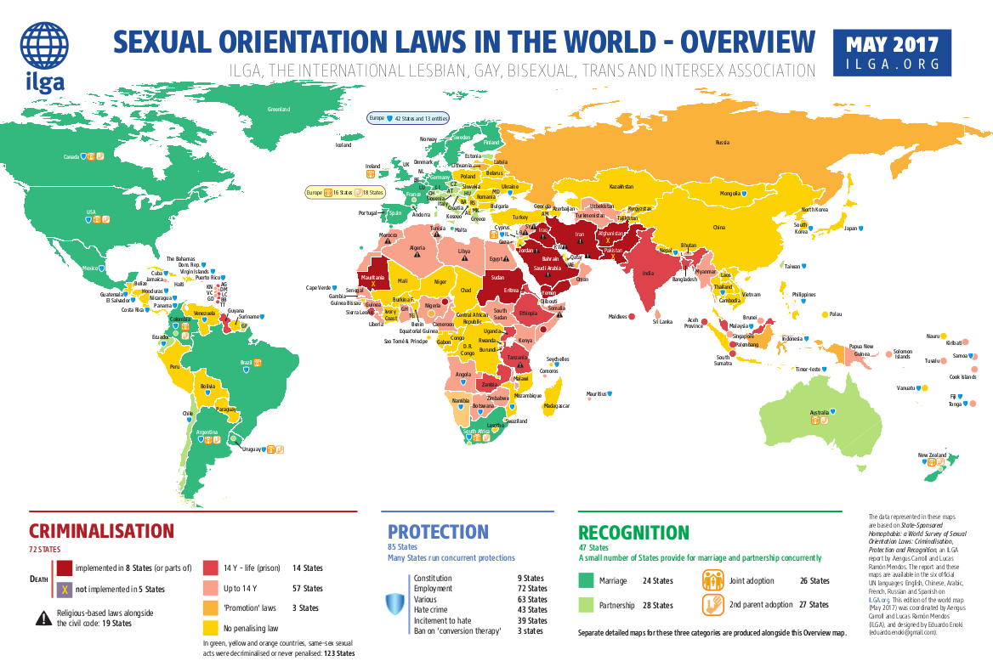
See the map below for an overview of sexual orientation laws around the world in terms of criminalisation, protection and recognition. (http://ilga.org/downloads/2017/ILGA_WorldMap_ENGLISH_Overview_2017.pdf)
PCS represents members in the UK but also many who may be posted overseas. We must try to ensure appropriate measures to protect our members are in place around the world. PCS does this by organising alongside international organisations on issues including human rights. (www.pcs.org.uk/campaigns/pcs-international)
You do not have to identify as LGBT in order to help fight Homophobia, Biphobia and Transphobia. You can help by showing solidarity with the LGBT community, sharing information such as this to educate people, support organisations who campaign for LGBT equality etc.
For more information please see the following links:
- PCS website: www.pcs.org.uk
- PCS Fylde Branch: http://www.pcsfylde.com/
- TUC Equality: www.tuc.org.uk/equality-issues
- LGBT History Month: www.lgbthistorymonth.org.uk
- Stonewall: www.stonewall.org.uk
- GIRES: www.gires.org.uk
- The Bisexual Index: http://www.bisexualindex.org.uk/
- Civil Service Rainbow Alliance: www.ukcsra.com
- A:Gender: www.agender.org.uk
