Step one- create a log in account on the PCS website.

https://join.pcs.org.uk/signup
Register now to use our online services

step two- click on members area along the top of the screen

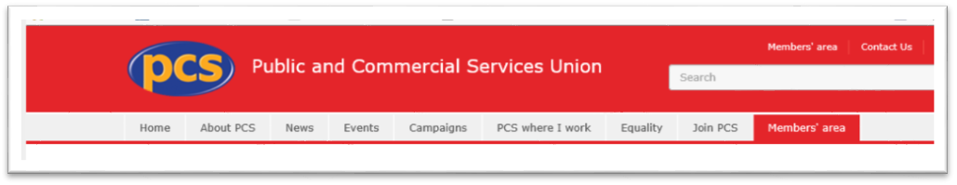
step three-Access imembership(commix)
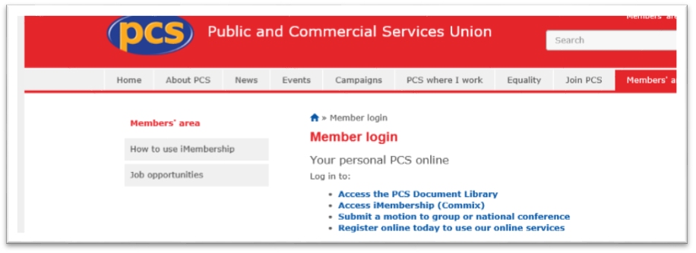
Step four-You can change your address and death benefit nominee
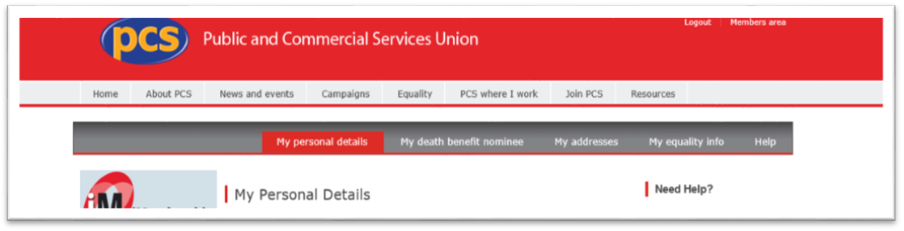

Step four-You can change your address and death benefit nominee
step three-Access imembership(commix)

