To All Members 
DWP/MB/010/19
4th March 2019

PCS DWP Group Celebrates
International Women’s Day - ‘Balance for Better’

8 March 2019

International Women's Day is celebrated on 8 March every year. It is a focal point in the movement for women's rights. In 1910 International Socialist Woman's Conference suggested a Women's Day be held annually. After women gained suffrage in Soviet Russia in 1917, 8 March became a national holiday there. It was subsequently adopted in 1975 by the United Nations. This years’ theme #BalanceforBetter is about focusing efforts on achieving parity for women however, two years of pay freeze – and let’s not forget that DWP staff were subjected to this before most other departments – followed by ten years of pay restraint (even accounting for the Employee Deal) has meant that our members who are predominantly women at 69 percent, have fallen up to a whopping 12 percent behind private and public sector pay. The Health and Wellbeing survey carried out in 2018 found that a massive 69 percent of the 35,000 respondents stated they experienced financial pressure in the preceding 12 months. This is not to say that men are not under financial pressure but, it is quite telling that the survey results on pay match our gender make up!
Pay restraint is also one of the reasons that the government’s target of closing the Gender Pay Gap is not being met. It also means this inequality will continue to plague women throughout their retirement years. Whilst the GDP is not as pronounced in the DWP as in other government departments, it is still to be highlighted, in particular, as staff are transferring to other departments more frequently than at any other time in Civil Service history. They do this often, according to a report published in January by the Institute For Government ‘Moving On’, to achieve pay progression and promotion. Turnover – staff transferring to other departments -is costing up to £74 million per annum. The report acknowledges the CS culture of promulgating itinerancy amongst staff to secure promotion
But, what of the women that can’t simply change departments because of care responsibilities? Or those who cannot simply jump ship to the likes of HMRC or Cabinet Office because they lack competencies and experience due to diminished opportunity and mobility?
It makes sense for the Civil Service to return to national pay bargaining. Pay increases would be mitigated in part, by lower turnover and women who cannot move would not suffer material detriment due to their circumstances.
Other things the DWP could consider is making more jobs filled by expression of interest open to job shares and promoting these as standard. Our part time workers – who are in the main women – should have the same career opportunities as others. It is initiatives and policies such as these, which will help close the gender pay gap and help our women members achieve career satisfaction and a better work-life balance.
The IWD theme is #BalanceforBetter and many women workers indeed walk a tightrope trying to finesse the art of staying upright. The DWP and the wider civil service need to put the policies in place to help them achieve this.
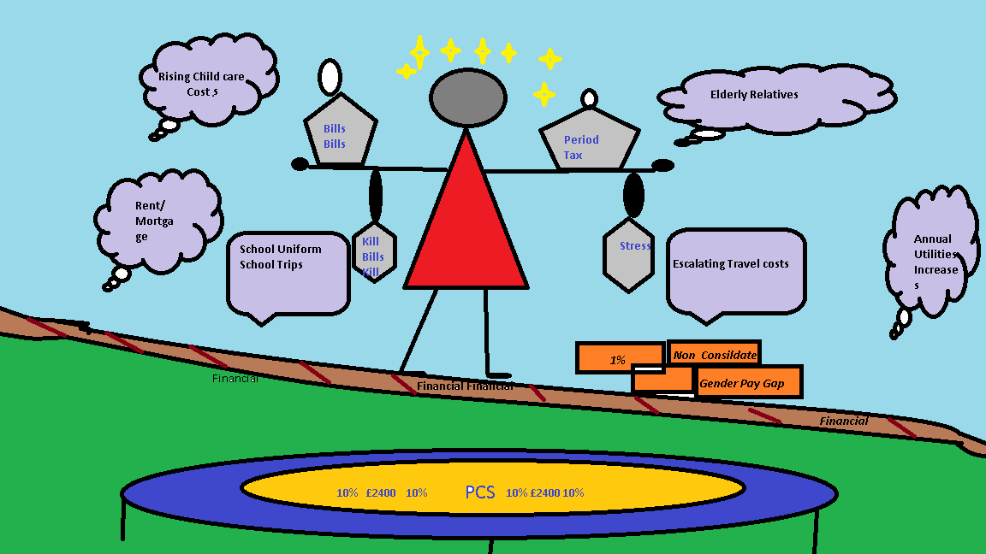
What could a 10% pay rise buy?
- 3 months childcare
- Family holiday
- Pay gas and electric bills for a year
- 22+ weeks of groceries
- 3 -6 months mortgage – excl London & SE
- 2-4 months rent – excl London & SE
- School dinners for 2 - 4 children per annum
Let us know what your branch is doing to mark IWD. Take pictures of events and send them PCS at leeds@pcs.org.uk

Please click on the link to see how much pay restraint has affected you
https://www.pcs.org.uk/campaigns/pcs-pay-campaign/pay-calculator
For further reading: -
https://www.gov.uk/government/publications/civil-service-diversity-inclusion-dashboard/civil-service-diversity-and-inclusion-dashboard
https://www.internationalwomensday.com/
https://www.pcs.org.uk/equality/guidance-and-resources/international-womens-day-iwd-2017
https://www.instituteforgovernment.org.uk/publications/moving-on-staff-turnover-civil-service
Please encourage non members to join PCS in our fight for Better Balance in pay, working conditions, opportunities and home life https://www.join.pcs.org.uk/

Annette Rochester
DWP Group Vice President

